**SMART PUBLIC RESTROOM**

**Objectives:**

The main objective of the Smart Public Restroom project is to create an intelligent and user-friendly public restroom facility that enhances the overall experience of users, improves cleanliness, and reduces maintenance costs. The project aims to achieve the following:

* Real-time Monitoring: Implement IoT sensors to monitor restroom conditions such as occupancy, water usage, soap availability, and trash levels.
* User-Friendly Experience: Develop a mobile app that allows users to find and access nearby smart public restrooms, check real-time occupancy status, and provide feedback.
* Maintenance Optimization: Enable predictive maintenance by collecting data from IoT sensors to schedule cleaning and restocking efficiently.
* Resource Efficiency: Integrate Raspberry Pi to control lighting, ventilation, and water management systems for energy and resource conservation.
* Code Implementation: Develop the necessary software for sensor data processing, communication, and control systems.

**IoT Sensor Setup:**

The IoT sensor setup is a crucial part of the project, responsible for collecting and transmitting data from the restroom. The setup may include the following sensors:

* Occupancy Sensors: These sensors detect the presence of users in the restroom, ensuring accurate occupancy data.
* Water Usage Sensors: Flow meters can monitor water consumption for faucets, toilets, and urinals.
* Soap Dispenser Sensors: Sensors on soap dispensers can monitor soap levels and detect when a refill is required.
* Trash Level Sensors: Ultrasonic or infrared sensors can monitor trash bin levels to trigger cleaning and emptying.

**Mobile App Development:**

The mobile app is a user interface that interacts with the IoT sensors and provides a user-friendly experience:

* Finding Restrooms: Users can locate nearby smart public restrooms using GPS and maps.
* Real-time Status: The app displays real-time information on restroom occupancy, availability of amenities, and cleanliness.
* Feedback Mechanism: Users can provide feedback on the cleanliness and maintenance of the restroom, helping improve service quality.

**Raspberry Pi Integration:**

Raspberry Pi is integrated to control various aspects of the restroom's infrastructure for resource efficiency. This may include:

* Lighting Control: Automatic lighting based on occupancy and ambient light conditions.
* Ventilation Control: Efficient ventilation based on occupancy and air quality monitoring.
* Water Management: Controlling water usage and ensuring no water is wasted.

**Code Implementation:**

The code implementation involves several components:

* Sensor Data Processing: Code to collect, process, and transmit data from IoT sensors to a central server or database.
* Server-Side Software: Backend code to manage restroom data, user feedback, and the mobile app interface.
* Mobile App Development: Creating the mobile app with features for locating restrooms, checking real-time data, and submitting feedback.
* Raspberry Pi Control: Developing code to control lighting, ventilation, and water management systems.
* Predictive Maintenance Algorithm: Implementing algorithms to schedule cleaning and restocking based on sensor data.
* Data Security: Ensuring data privacy and security, especially when handling user feedback and restroom usage data.
* User Interface (UI) and User Experience (UX) Design: Designing a user-friendly interface for the mobile app to enhance the user experience.

The successful integration of these components will result in a Smart Public Restroom system that offers real-time monitoring, resource efficiency, and a convenient user experience, contributing to cleaner and more efficient public facilities.

**Smart Public Restroom:**

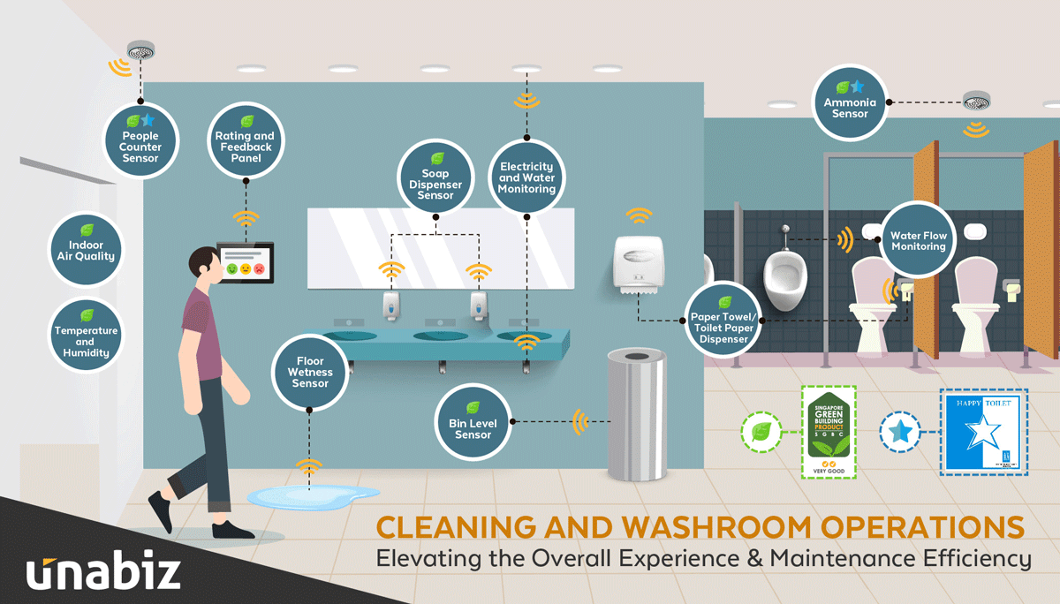

**IoT Sensors Setup:**

* Occupancy Sensors: These are typically small motion or infrared sensors placed above restroom entrances to detect the presence of users.
* Water Usage Sensors: Flow meters attached to water supply lines for faucets, toilets, and urinals.
* Soap Dispenser Sensors: These could be sensors on or inside soap dispensers, measuring soap levels.
* Trash Level Sensors: Ultrasonic or infrared sensors installed inside trash bins.

**Restroom Information Platform:**

* Central Server: The server collects data from IoT sensors and processes it. It manages the entire system and serves as the backend for the mobile app.
* Database: Data from the sensors is stored in a database for historical analysis and real-time access.
* Predictive Maintenance Module: An algorithm that uses the sensor data to predict maintenance needs and schedules cleaning and restocking.
* Communication Protocols: The system may use MQTT, HTTP, or other protocols to facilitate data exchange between sensors, Raspberry Pi, and the server.

**Mobile App Interfaces:**

* Home Screen: Displays a map showing nearby smart public restrooms and their real-time occupancy status.
* Restroom Details: After selecting a restroom, users can view occupancy status, availability of amenities, and user feedback.
* Feedback Form: A feature allowing users to submit feedback regarding cleanliness and maintenance.
* User Profile: Where users can manage their account, preferences, and view their submission history.

**FLOW CHART:**

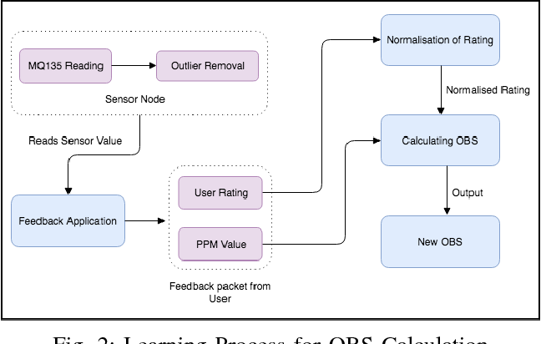

**A real-time restroom information system can greatly enhance the user experience and restroom management in several ways:**

**Program:**

**# Import necessary libraries and modules**

**import flask**

**from flask import request, jsonify**

**import sqlite**

**app = flask.Flask(__name__)**

**# Create a SQLite database for storing sensor data and user feedback**

**def create_database():**

**conn = sqlite3.connect('restroom_data.db')**

**cursor = conn.cursor()**

**cursor.execute('''**

**CREATE TABLE IF NOT EXISTS occupancy (**

**timestamp TIMESTAMP,**

**restroom_id INTEGER,**

**occupancy_status BOOLEAN**

**)**

**''')**

**cursor.execute('''**

**CREATE TABLE IF NOT EXISTS user_feedback (**

**timestamp TIMESTAMP,**

**restroom_id INTEGER,**

**cleanliness_rating INTEGER,**

**maintenance_rating INTEGER,**

**comments TEXT**

**)**

**''')**

**conn.commit()**

**conn.close()**

**# API route to receive sensor data**

**@app.route('/api/sensor_data', methods=['POST'])**

**def receive_sensor_data():**

**data = request.get_json()**

**# Store the data in the database**

**conn = sqlite3.connect('restroom_data.db')**

**cursor = conn.cursor()**

**cursor.execute('INSERT INTO occupancy VALUES (?, ?, ?)', (data['timestamp'], data['restroom_id'], data['occupancy_status']))**

**conn.commit()**

**conn.close()**

**return "Sensor data received", 201**

**# API route for users to submit feedback**

**@app.route('/api/submit_feedback', methods=['POST'])**

**def submit_feedback():**

**data = request.get_json()**

**# Store user feedback in the database**

**conn = sqlite3.connect('restroom_data.db')**

**cursor = conn.cursor()**

**cursor.execute('INSERT INTO user_feedback VALUES (?, ?, ?, ?, ?)',**

**(data['timestamp'], data['restroom_id'], data['cleanliness_rating'],**

**data['maintenance_rating'], data['comments']))**

**conn.commit()**

**conn.close()**

**return "Feedback submitted", 201**

**# API route to retrieve restroom data for the mobile app**

**@app.route('/api/get_restroom_data', methods=['GET'])**

**def get_restroom_data():**

**# Fetch and format data from the database**

**conn = sqlite3.connect('restroom_data.db')**

**cursor = conn.cursor()**

**cursor.execute('SELECT * FROM occupancy ORDER BY timestamp DESC LIMIT 1')**

**latest_occupancy = cursor.fetchone()**

**cursor.execute('SELECT * FROM user_feedback WHERE restroom_id = ?',**

**(latest_occupancy[1],))**

**feedback_data = cursor.fetchall()**

**conn.close()**

**# Return data as JSON**

**response = {**

**'latest_occupancy': {**

**'timestamp': latest_occupancy[0],**

**'occupancy_status': latest_occupancy[2]**

**},**

**'user_feedback': [{**

**'timestamp': feedback[0],**

**'cleanliness_rating': feedback[2],**

**'maintenance_rating': feedback[3],**

**'comments': feedback[4]**

**} for feedback in feedback_data]**

**}**

**return jsonify(response)**

**if __name__ == '__main__':**

**create_database()**

**app.run(debug=True)**

* **For Users:**
* **Improved Convenience:**

Users can check the real-time occupancy status of restrooms, ensuring they don't waste time waiting in line for an available stall or urinal. This convenience is especially important in high-traffic public spaces.

* **Enhanced Hygiene:**

Users can access information on the cleanliness of the restroom and the availability of soap, reducing the risk of encountering unsanitary conditions.

* **Time Savings:**

By knowing which restrooms are available nearby and their occupancy status, users can plan their restroom breaks more efficiently, saving time during busy periods.

* **User Feedback:**

The system allows users to provide feedback on restroom cleanliness and maintenance. This feedback loop empowers users to contribute to improvements.

* **Accessibility:**

Users with specific needs, such as those requiring accessible facilities, can quickly locate restrooms that meet their requirements.

* **For Restroom Management:**

* **Predictive Maintenance:**

The system collects data from IoT sensors, enabling predictive maintenance scheduling. This reduces unnecessary cleaning and restocking trips and optimizes resource allocation.

* **Resource Efficiency:**

Restroom management can control lighting, ventilation, and water usage more efficiently, reducing operational costs and environmental impact.

* **Real-time Monitoring:**

Management can monitor restroom conditions in real-time and receive alerts when issues arise, enabling swift response to emergencies or urgent cleaning needs.

* **Data-Driven Decision Making:**

Access to historical and real-time data allows management to make informed decisions regarding restroom maintenance, staffing, and resource allocation.

* **User Satisfaction:**

By addressing user feedback and maintaining clean and well-stocked facilities, management can increase user satisfaction and create a positive impression of the facility.

* **Traffic Flow Management:**

The system can provide insights into restroom usage patterns, helping to manage traffic flow within the facility during peak hours.

* **Operational Cost Reduction:**

By optimizing cleaning and maintenance schedules and resource usage, operational costs can be reduced, leading to potential cost savings.